**EXCEL ASSESSMENT FOR ANALYST ROLE**

**Using the sample Data set provided for you, answer the below questions: Note: Each question should be done on a sheet carrying the question number, save the file using your EMP Code & Name.**

1. Using the sheet named “Branch & Customer Mapped Master” on the data set file, crate an additional column and indicate “ACCEPTED” if the MappedCust is equal to or more than 100 OR “NOT ACCEPTED” if less than 100 (5 marks)
2. On a separate Sheet named Question 2, evaluate for each of the row in Column E on “Branch & Customer Mapped Master” using the below condition

Mapped Customers between “170 and above”, GRADE A

Mapped Customers between “150 to 169”, GRADE B

Mapped Customers between “130 to 149”, GRADE C

Mapped Customers between “100 to 129”, GRADE D

Mapped Customers between “50-99”, GRADE E

Mapped Customers between “0 to 49”, GRADE F

(10 mks)

1. Using LOOK UP, add Branch to each of the Salesman in sheet “Redistribution Data” (5 mks)
2. Using Error Handling function, all salesmen without branches according should have “BRANCH MISSING” (5 mks)
3. Using Pivot Table, Evaluate Branch-wise, Product Wise, Month wise Total Touch Point and RedQty, with a very decent formatting (5 mks)
4. Please use the Data set to get similar table (detailed) as seen in below screenshot (40mks)

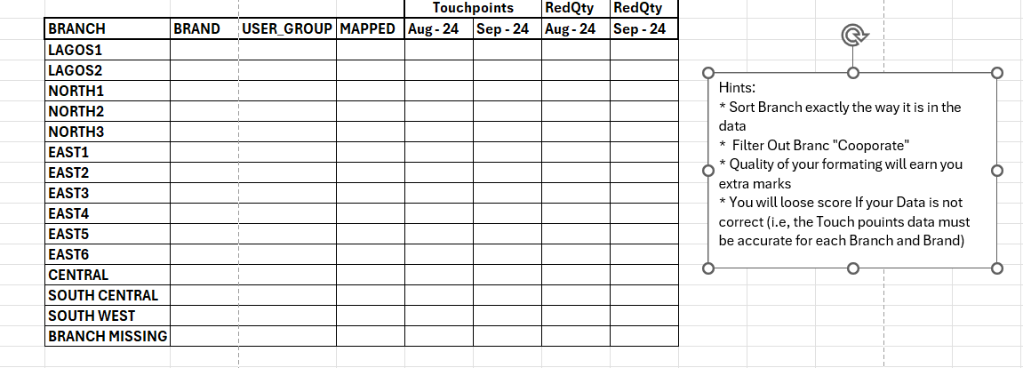

1. Make a Power point presentation to share your insights from the Data sets to advise a Sales manager.